**CS 1400 Fundamentals of Programming**

**Programming Project #8**

**Bowling Team Scores**

**Version 1.0**

**Objective:**

At the completion of this Project, you will have created an application that:

* gets input from the user and stores it in two arrays,
* uses arithmetic expressions, assignment, and control structures,
* uses the ***Split*** method of the ***string*** class to parse user input, then
* formats the output and sends it to the ***Console*** or ***GUI*** to display, you may choose.

**Project:**

Knowing that you are a budding programmer, your friends have asked you to create a scoring program for your Saturday bowling league.

They want the program to work as follows:

* At the end of each game, the program asks you to record the scores for each team member. You then type in their first name and that person's score for the game on a single line.
* Your program uses the ***Split*** method to parse the input. The ***name*** is stored in an ***array of strings*** and the ***score*** is stored in an ***array of integers***.
* When there are no more players to input, have the user enter an empty line.
* Your program should now list each bowler and their score. Remember the bowling score has to be in the range ***0-300***!
* It will then calculate the ***highest score*** for the game, and display a message showing the ***high score*** and who it was.
* The program will calculate the ***lowest score*** for the game, and display a message showing the ***low score*** and who it was.
* The program will compute the ***average score*** and display it.

**Design Considerations**

You should design and use a class that represents a bowling team. Think carefully about the state information of a bowling team that would be important for this application. For example, you would need an array to hold the names of the bowlers on your team. What other data members and member methods would you need?

Your program should work for ***any number of players*** on a team, up to ***10***.

You may write this as a Console Application or as a GUI application. In either case, the program should work as outlined.

Format and document your code in accordance with the course Style Guidelines.  Include a Project Prolog identifying you as the author as well as the required method prologs. Submit your project to Canvas.

**File(s) to Submit:**

Place your entire Project folder into a zip file and name the zip file  
Proj_08_your-initials_V1.0.zip. For example, I would name my file Proj_08_DAF_V1.0.zip. Submit this assignment as Project #8 on Canvas.

**Hints**

If you need some help writing the code for this project, here are some hints shown below:

**Hints for Project Eight**

1. Use an integer variable to keep track of how much data is in your arrays, this will help in dealing with a partially filled array.
2. When the user hits the Enter key to signal the end of their input, the resulting string will be empty. You can test this by writing

**if ( userString == "")**

1. The user will type a name and a score on one line and hit the Enter key. To parse the input string you will need code something like the following:

**string userInput = null;**  // the line of data input by the user is stored here  
    **string[] parsedInput = null;** // userInput is split into two pieces,

// stored in this array of strings  
    **parsedInput = userInput.Split();** // this line splits the string *userInput*

// into the two pieces  
    **string name = parsedInput[0];** // store the first piece, the name, in a string

// variable  
    **int scoreTemp = 0;** // an integer variable

**If(int.TryParse(parsedInput[1], out score)** // store the second piece, a score,

**scores[idx] = scoreTemp;**

1. If you write a GUI application, you might want to trigger an event when the user presses the ***Enter Key***. The following code will check to see if a KeyPress while in a TextBox is the ***Enter Key***. It then gets the data from the TextBox.

**private void inputTxtBox_KeyPress(object sender, KeyEventArgs e)  
{  
   // see if the enter key was pressed  
   if (e.KeyData == (char)Keys.Enter)  
   {  
      // if it was, get the data from the text box  
      string inputString = inputTxtBox.Text;  
       ...**

|  |  |  |
| --- | --- | --- |
|  | **Grading Checklist** |  |
| # | Program | C(correct)  X(incorrect) |
| 1 | Meets & works to specifications | 6 points |
| 2 | Error Free, elegant & efficient | 4 points |
| 3 | Pseudo-Code | -3 points |
| 4 | Style Guidelines | -2 points |
| 6 | Source Files(s) & Formatting | -2 points |
| 7 | Project Prolog | -1 points |
| 8 | Function Prologs | -1 points |
| 9 | Zip Filename | -1 points |
| 10 | Lab & Project Names | -1 points |
| 11 | Zip File is invalid or will not unzip | Lab = 0 pts |
|  | Total Points | 10 | 0-9 |

**Sample Output:**

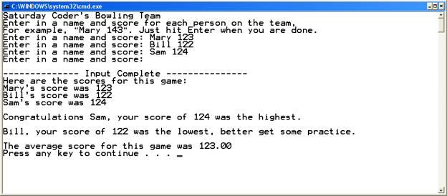

You can get a Console executable and GUI executable that runs correctly on Canvas.